Test preparation HW#1: Solution
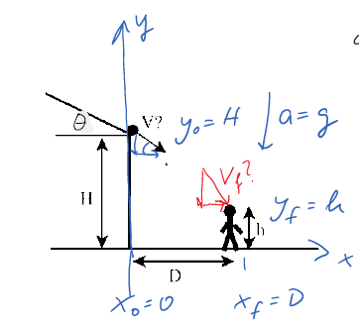
$$\begin{matrix} & \text{a)} x=x_{0}+v_{0x}t+\frac{1}{2}a_{x}t^{2} \\ & D=V_{0}cos⁡θt→t=\frac{D}{V_{0}cos⁡θ} \\ & y=y_{0}+v_{0}t+\frac{1}{2}a_{y}t^{2} \\ & h=H+\left(-v_{0}sin⁡θ\right)t+\frac{1}{2}(-g)t^{2} \\ & h=H-V_{0}sin⁡θ\left(\frac{D}{v_{0}cos⁡θ}\right)-\frac{1}{2}g\left(\frac{D}{v_{0}cos⁡θ}\right) \\ & h=H-Dtan⁡θ-\frac{1}{2}g\frac{D^{2}}{V_{0}^{2}\cos^{2}⁡θ} \\ & \frac{1}{2}g\frac{D^{2}}{v_{0}^{2}\cos^{2}⁡θ}=H-h-Dtan⁡θ \\ & V=\sqrt{\frac{D^{2}g}{2\cos^{2}{θ\left(H-h-\operatorname{Dtan}{θ}\right)}}}\end{matrix}$$

b)
$$\begin{matrix}v_{x}=v_{0x}+a_{x}t \\ v_{x}=vcos⁡θ \\ v_{y}^{2}=v_{0y}^{2}+2a_{y}\left(y-y_{0}\right) \\ v_{y}^{2}=(-vsin⁡θ)^{2}+2(-g)(h-H) \\ v=\sqrt{v_{x}^{2}+v_{y}^{2}}=\sqrt{{\left(vcos⁡θ\right)}^{2}+(vsin⁡θ)^{2}+2(g)(H-h)} \\ v=\sqrt{v^{2}+2g(H-h)}\end{matrix}$$

T Prep HW 1: Forces
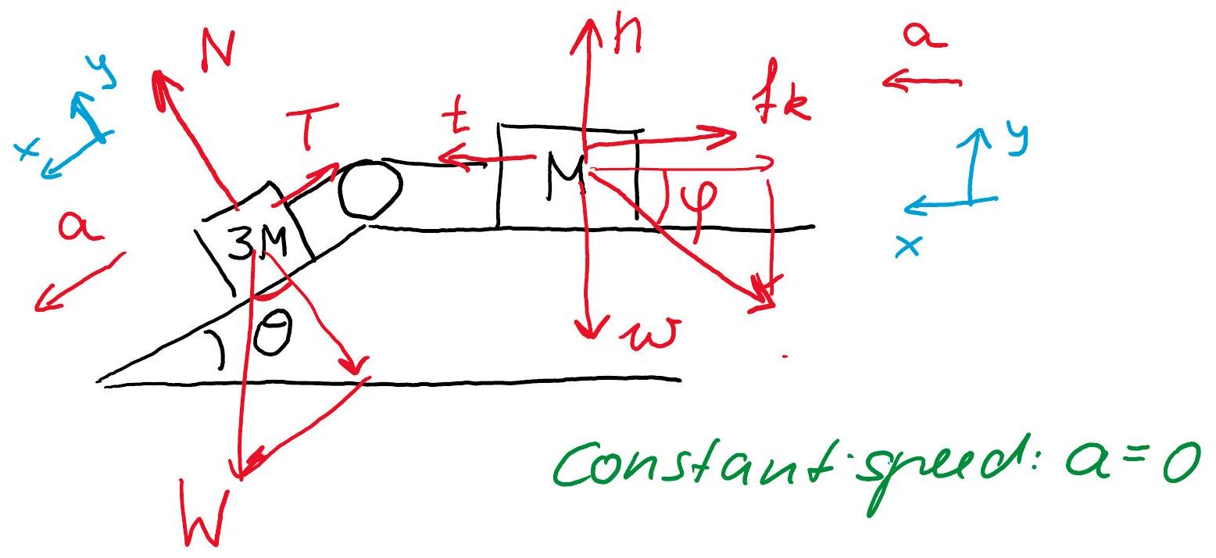
Block 3M:

$$\begin{matrix}\sum{ }F_{x}=N_{x} & +T_{x}+W_{x}=3Ma_{x} \\ -T & +3Mgsin⁡θ=0⇒T=3Mgsin⁡θ\end{matrix}$$
Block M:
$$\begin{matrix} & \sum{ }F_{x}=N_{x}+t_{x}+P_{x}+f_{kx}+w_{x}=Ma_{x} \\ & t-Pcos⁡φ-f_{k}=0 \\ & 3Mgsin⁡θ-Pcos⁡φ-f_{k}=0 \\ & f_{k}=3Mgsin⁡θ-Pcos⁡φ\end{matrix}$$
$$\begin{matrix} & f_{k}=μn \\ & \sum{ }F_{y}=n_{y}+t_{y}+P_{y}+f_{ky}+ω_{y}=Ma_{y} \\ & n-Psin⁡φ-Mg=0 \\ & n=Mg+Psin⁡φ \\ & μ=\frac{f_{k}}{n}=\frac{3Mgsin⁡θ-Pcos⁡φ}{Mg+Psin⁡φ}\end{matrix}$$

T Prep HW 1: Circular
post
M
M
2L
L

$$\begin{matrix}\sum{ }F_{x}=N_{1x} & +T_{1x}+W_{1x}+T_{1x}=Ma_{1x} \\ T_{1}-T_{2}=M\frac{V^{2}}{L} & \end{matrix}$$

$$\begin{matrix}\sum{ }F_{x}=N_{2x} & +W_{2x}+T_{2x}=Ma_{2x} \\ T_{2}=M\frac{{\left(2V\right)}^{2}}{2L} & =2M\frac{V^{2}}{L}\end{matrix}$$
(same period at double radius means speed of outer block is 2V)

$$T_{1}=M\frac{V^{2}}{L}+T_{2}=3M\frac{V^{2}}{L}$$

